**XAMPP and MySQL Setup**

Name: Kennedy Kabaso.

Strayer University.

Week 5 Lab 3

CIS 111

Intro To Relat Dbase Mgt Syst

Professor: Besharatian Hossein.

November 6, 2017

**Table of Content.**

**Cover Page -------------------------------------------------------------------------------------- Page 1**

**Lab Report --------------------------------------------------------------------------------------- Page 3**

**Screen shots-------------------------------------------------------------------------------------- Page 5**

**Bibliography ------------------------------------------------------------------------------------- Page 8**

**XAMPP and MySQL Setup**

1. **Describe your experiences related to your setup of MySQL. Include any difficulties or issues that you had encountered during the installation.**

The installation went straight forward for me because I followed the instruction on the link which was provided which was  [http://www.easyphp.org](http://www.easyphp.org/). I downloaded and installed a Devserver for Windows 7/8/10 completely which is an open source and ready to use development environment. In addition, it is portable, modular, fully configurable and easy to update and extend. It included PHP, Apache and MySQL. I found it easy to use once everything was done. I could run my MySQL on the main screen by open the MySQL Administration ( PhpMyAdmin 4.7.0) and different staffs on the databases.

1. **Based on your post-installation research, describe the main capabilities of MySQL.**

MySQL is a database management system. If you want to add, access, and process data stored which in a computer database, MySQL server database management system is the best choice for the job. The databases are relational which stores data in separate tables rather than putting all the data in one big storeroom. This software is Open Source which make it possible for anyone to use and modify it. The Database Server is very fast, reliable, scalable, and easy to use. Moreover, the Server can run without any problem on a desktop or laptop. In addition, it works in client/server work environment. Moreover, its supports client programs that use Open Database Connectivity to connect to MySQL server from other databases like Ms Access.

1. **Describe the approach that you would take to go from a conceptual or logical model that you created to the implementation of that database structure in MySQL. Determine the additional information that you will need to implement the database design in a database management system**.

During the physical design process, you convert the data gathered during the logical design phase into a description of the physical database, including tables and constraints. Physical design decisions, such as the type of index or partitioning have a large impact on query performance. The process of logical design involves arranging data into a series of logical relationships called entities and attributes.

The additional information which is needed to implement the database design in a database management system is the normalization of the tables which is important to eliminate redundancy and potential update anomalies. Then you move to the physical design which will lead to the implementation of the database. After the above-mentioned process is done, the data can be added which can be tested. In addition, some application programs can be designed.

1. **Include the screen shot which shows that MySQL is installed on your computer.**

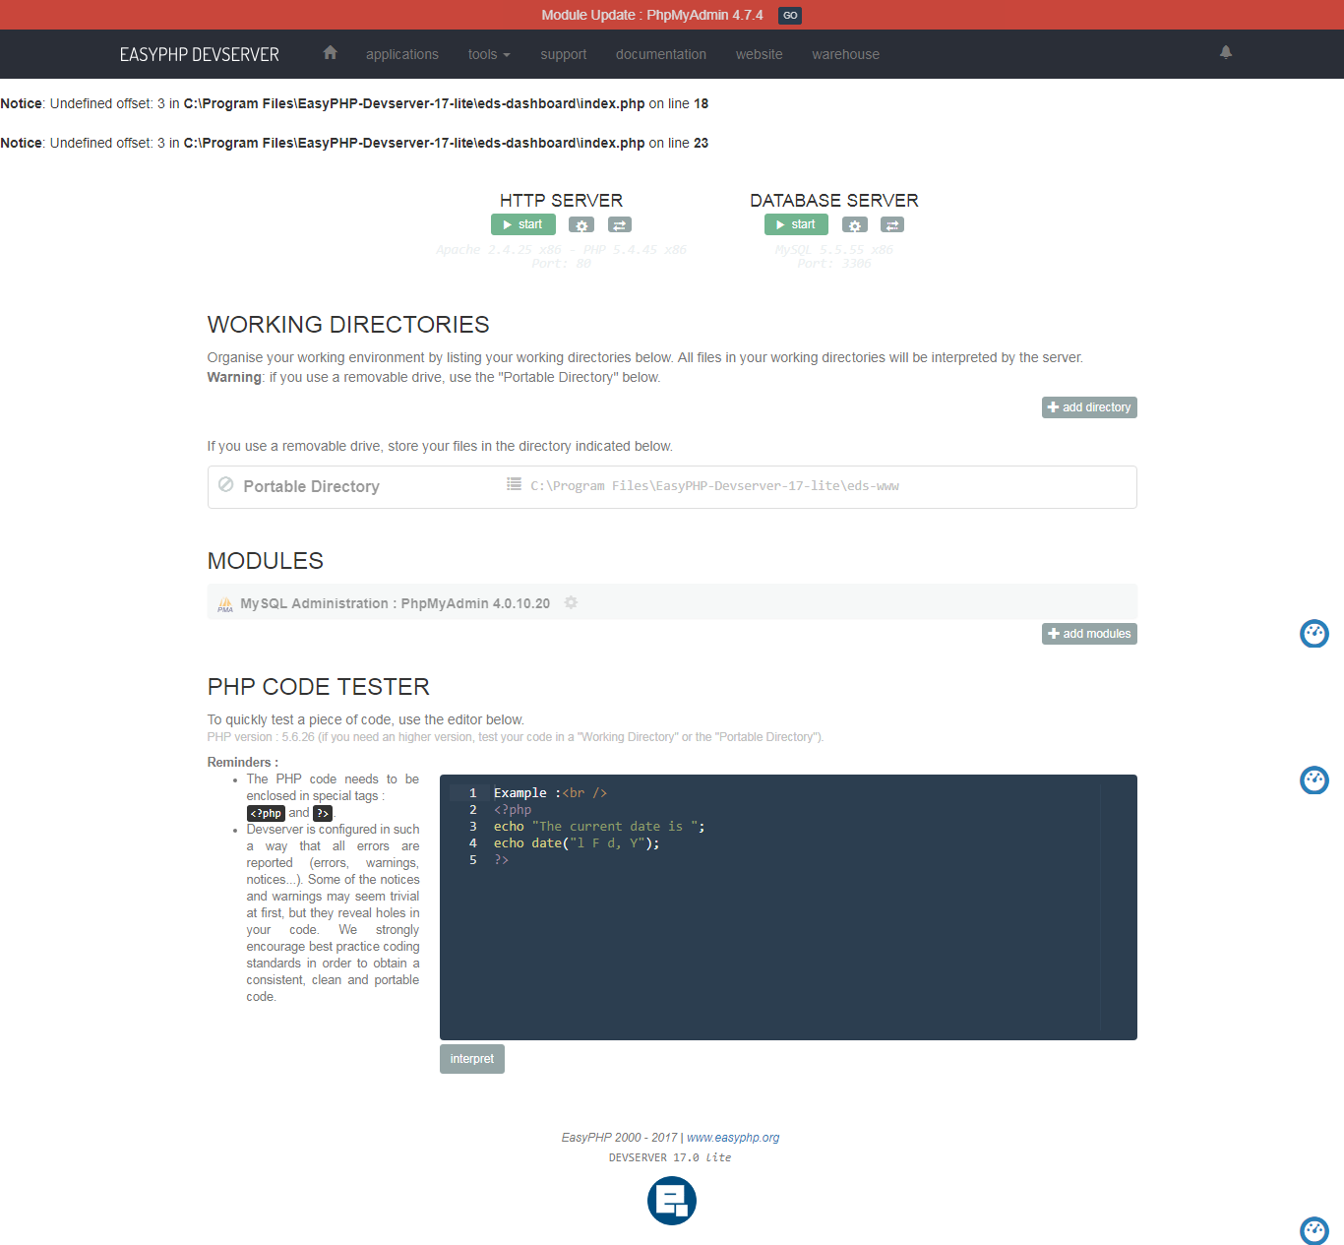

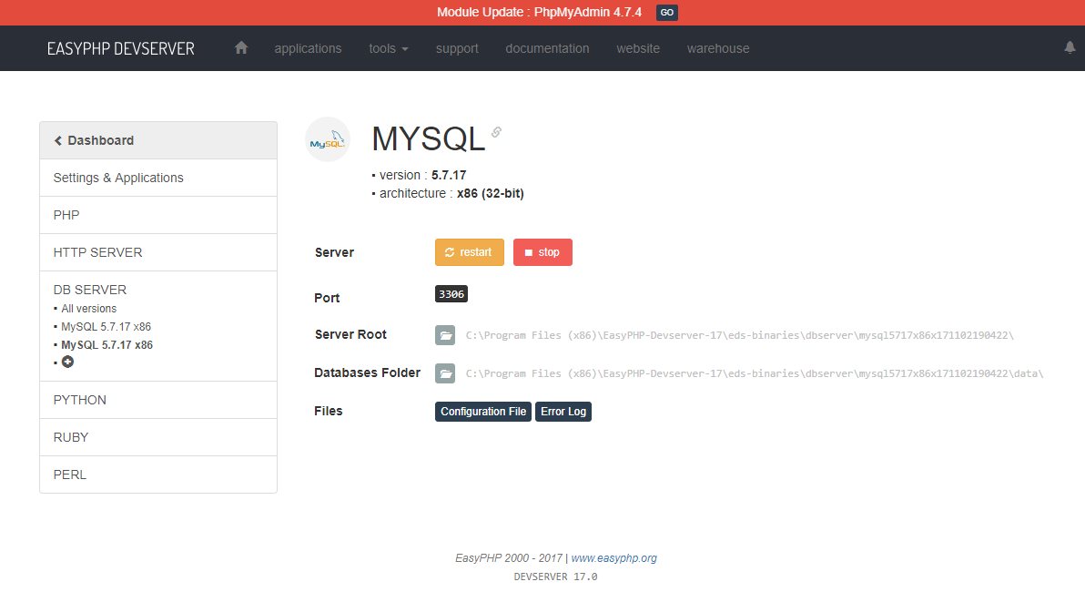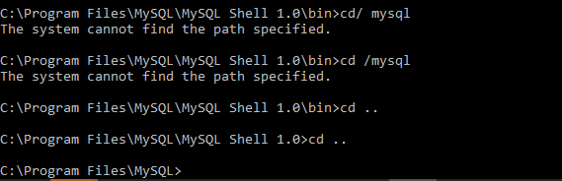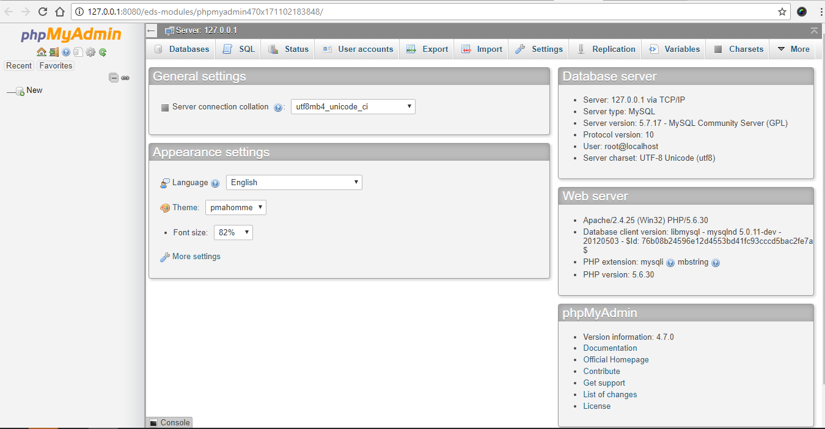

**Bibliography**

1. <https://dev.mysql.com/doc/refman/5.7/en/features.html>
2. <http://www.easyphp.org/>
3. https://blackboard.strayer.edu/bbcswebdav/institution/CIS/111/1144/Install_EASYPHP_Instructions_3-4-2014.pdf